We are now operating in a very unusual tech market from an equity value and multiples perspective. Starting around 9 months ago, tech equities across the board started to see sharp price and multiple compression on the fear of AI impact on their businesses. This was a broad-based impact on the tech sector while over the same period, the S&P traded up 4%. Normally, we see a high correlation between the S&P and tech; in this case we have a distinct decoupling.
So, the question I asked is, does this decoupling and value reduction correlate to the most important leading indicator in the tech business, NARR?
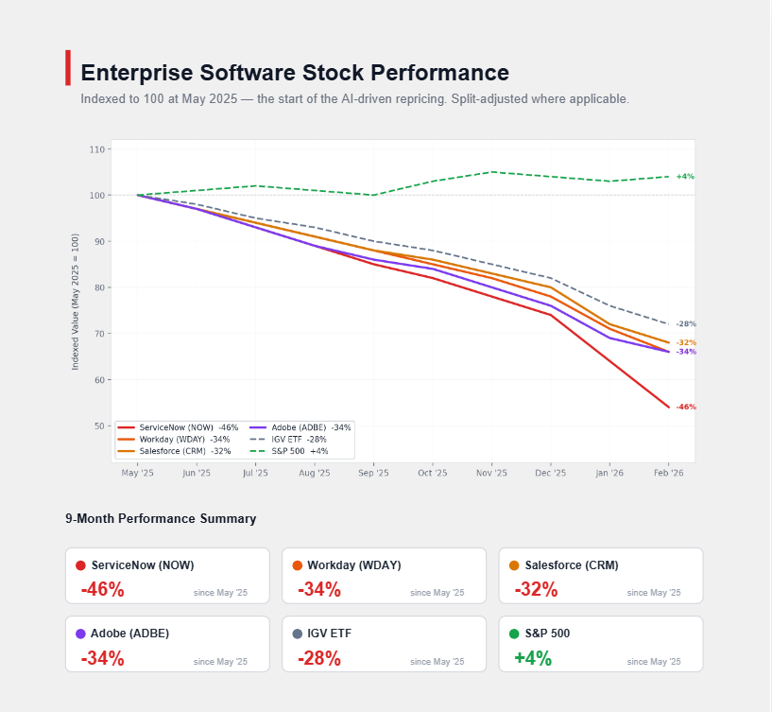

The Big 3 hyperscalers generated ~$80 billion of NARR last year
All three hyperscalers reported Q4 2025 (calendar) results in late January and early February 2026, providing clean year-over-year comparisons. The NARR math is straightforward: take each provider's Q4 2025 quarterly revenue, multiply by four, and subtract the same calculation for Q4 2024. This is a proxy calculation admittedly but will be a fair representation of NARR and overall ARR trends.
AWS reported $35.58 billion in Q4 2025 revenue versus $28.79 billion a year earlier, yielding $27.2 billion in NARR. Growth reaccelerated to ~24%, the fastest rate in 13 quarters, pushing AWS to a $142 billion annualized run rate. Amazon announced ~$200 billion in planned 2026 capex, much of it AI infrastructure.
Microsoft Intelligent Cloud posted $32.9 billion in its fiscal Q2 2026 (ending December 2025), up from $25.5 billion in the year-ago period, producing $29.6 billion in NARR — the largest absolute contribution of any single cloud segment. Azure specifically grew 39% year-over-year, Microsoft with AI services contributing a meaningful portion. Microsoft Cloud revenue overall surpassed $50 billion for the quarter.
Google Cloud delivered the fastest growth at 48%, reporting $17.66 billion in Q4 2025 versus $11.95 billion a year earlier, generating $22.8 billion in NARR. Google Cloud's backlog more than doubled to $240 billion, signaling continued acceleration. Alphabet announced $175–185 billion in 2026 capital expenditure plans.
Provider | Q4 2025 Revenue | Q4 2024 Revenue | YoY Growth | NARR
AWS | $35.58B | $28.79B | ~24% | $27.2B
Microsoft Intelligent Cloud | $32.91B | $25.50B | ~29% | $29.6B
Google Cloud | $17.66B | $11.95B | ~48% | $22.8B
Combined | $86.15B | $66.24B | ~30% | ~$79.6B

OpenAI and Anthropic together hit ~$22 billion in NARR
Both these AI companies are private, so figures come from executive disclosures, press reports, and investor documents rather than audited financials.
OpenAI ended 2025 at $20 billion+ ARR, per CFO Sarah Friar's January 18, 2026 blog post, which detailed a trajectory from $2B in 2023 to $6B in 2024 to $20B+ in 2025. PYMNTSSherwood News The growth curve was steep throughout 2025: roughly $6B in January, $10B by June, PYMNTS $13B by August, Sacra and $20B+ by December. Using a baseline of ~$6–7 billion in early 2025, OpenAI generated approximately $13–14 billion in net new ARR. The company has targeted $25B in 2026 revenue, The Motley Fool suggesting its early 2026 run rate may already exceed $20B.
Anthropic reached $9 billion+ ARR by end of 2025, per Bloomberg (January 21, 2026). Bloomberg The company started 2025 at roughly $1 billion ARR — confirmed in Anthropic's own Series F fundraising materials — and grew explosively: Anthropic $1.4B by March, Inc.com $5B+ by August, Anthropic and $9B+ by December. Bloomberg Net new ARR was approximately $8 billion. Anthropic projects $18 billion in 2026 revenue, Yahoo Finance implying continued rapid acceleration. The Motley Fool
Company | ARR (End 2025) | ARR (~Early 2025) | Net New ARR
OpenAI | $20B+ | ~$6–7B | ~$13–14B
Anthropic | $9B+ | ~$1–1.3B | ~$8B
Combined | ~$29B+ | ~$7–8B | ~$21–22B
These figures exclude Microsoft's licensing revenue from OpenAI's technology.

The large-cap SAAS cohort collectively generated $25–37 billion of NARR
The "balance of large-cap tech" category is the most definition-dependent. The answer ranges from ~$25 billion to ~$37 billion based on which companies and revenue streams are included.
The pure-play SaaS cohort — Salesforce, ServiceNow, Adobe, Workday, CrowdStrike, Palo Alto Networks, Snowflake, Datadog, and similar companies — generated approximately $25 billion in NARR, closely matching the low end of the range. The largest contributors were Salesforce ($3.3B), ServiceNow ($2.4B), Shopify ($2.7B), Intuit ($2.4B), Adobe ($2.3B), and Palantir ($2.3B, growing 70% YoY on AI demand).
The picture changes substantially when SAP and Oracle enter the frame. SAP's cloud revenue grew 19% to produce $3.7 billion in NARR as customers migrate from on-premise licenses. Oracle is the wildcard: its cloud infrastructure (OCI) segment surged 68% year-over-year, driven by GPU capacity for AI workloads, generating $8.1 billion in total cloud NARR. Including Oracle's full cloud business pushes the category above $35 billion; including only its SaaS applications yields ~$30 billion.
Segment | Approximate NARR
Tier 1: Salesforce, ServiceNow, Adobe, Workday | ~$9.1B
Tier 1: SAP cloud + Oracle cloud | ~$11.9B
Tier 2: CrowdStrike, Palo Alto, Snowflake, Datadog, Intuit, Shopify | ~$9.2B
Tier 3: Palantir, Atlassian, Cloudflare, HubSpot, Twilio, Zscaler, others | ~$6.6B
Total (all companies, full cloud) | ~$36.8B
Total (excluding OCI infrastructure) | ~$30.2B
Total (pure-play SaaS only, no SAP/Oracle) | ~$24.9B
The $25 billion figure is most accurate when scoped to pure-play SaaS companies and excludes Oracle's infrastructure cloud. A more complete definition brings us to the $367 B NARR upper end of the range.

The full picture reveals where tech NARR is actually occurring…
Summing across all three categories produces a total of roughly $123–132 billion in net new annualized revenue, broadly confirming the $125 billion headline.
- Hyperscalers: ~$80B – three companies; AI centric / AI infrastructure
- AI Leaders : ~$22B - two companies; pure AI
- Large-cap SaaS: ~$25–37B comprised of many companies in the rest of the tech industry; early stage AI featured products (notable exception is Oracle Cloud which is AI infrastructure)
The most striking outcome is the sheer concentration of NARR in the AI leaders. 5 companies comprise approximately 75% of all of tech NARR last year. This is an astonishing concentration of NAAR and therefore growth.
For the SaaS cohort, there are outliers — Palantir at 70% growth and , Yahoo Finance Shopify at 32% StockAnalysis — are those most directly benefiting from AI integration or platform expansion. The $25 billion figure for this group, while approximately correct, masks enormous variance: Oracle's cloud infrastructure alone generates more NARR than ServiceNow, Snowflake, and CrowdStrike combined.
One final caveat: the NARR framework compares annualized quarterly run rates, which overstates growth for companies with seasonal revenue patterns and understates it for companies still accelerating within the year. It is an approximation, not an absolute measure for NARR. But as a directional gauge of where technology spending is flowing, the ~75% concentration of NARR in five companies is evident.
Conclusions
The tech market is struggling to adjust to the overall long term AI impact. This is not isolated to a single segment of tech – it is broad based and pronounced and it is not clear if this will be a long term impact on non AI tech stock multiples.

For me, several questions come to mind:
* Should we feel a greater sense of urgency to significantly increase our investment and effort in AI/GAI
* Should we place more emphasis on the value of a potential combination with a large cap tech company to secure more distribution scale

